# Data Cleaning & Modeling :

* Fix missing fuel consumption values

Relate Trips with Vehicle Master

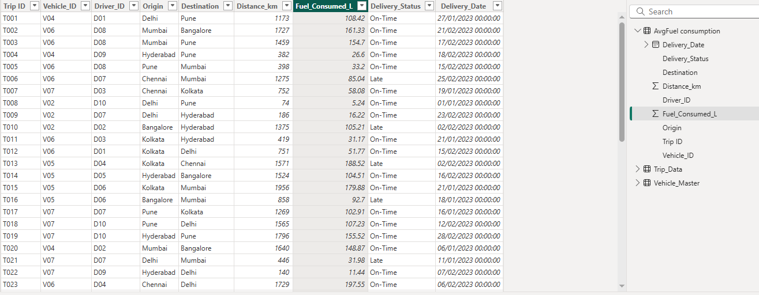

## DAX Measures:

Fuel Efficiency :

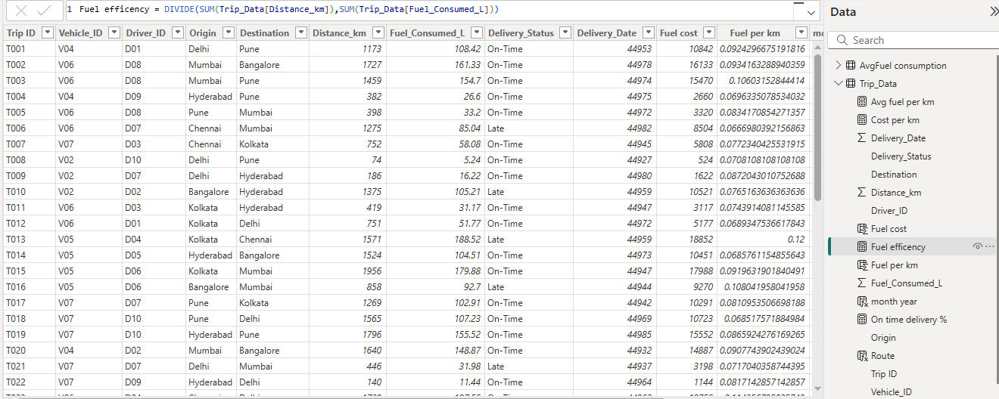

On-Time Delivery %

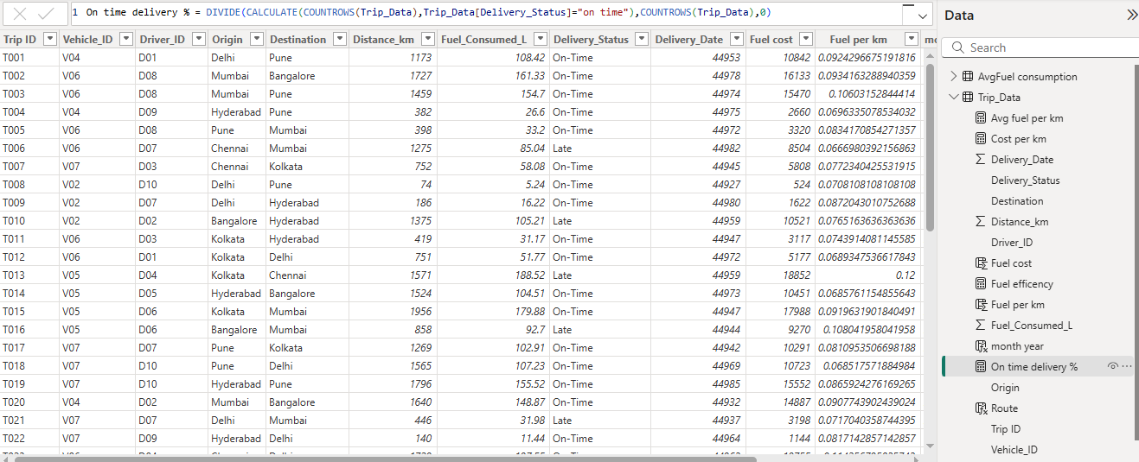

Cost per km

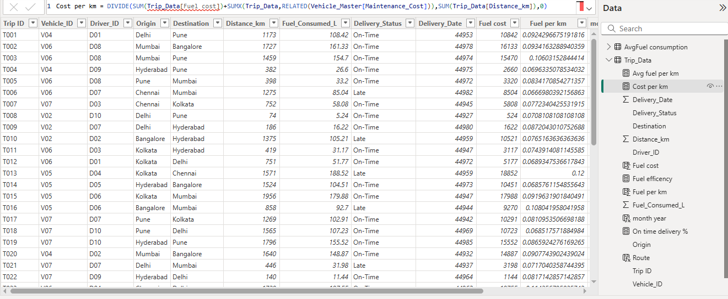

# Visualization:

